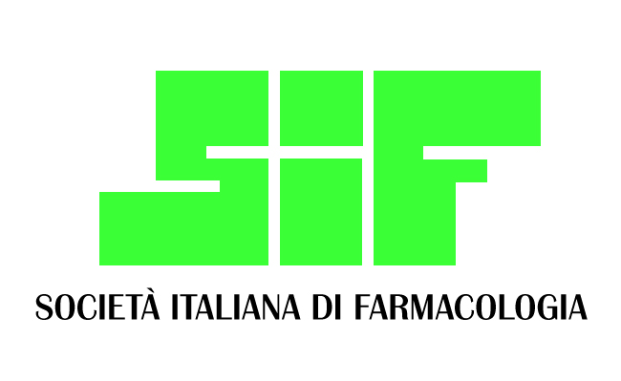 | SIF - FARMACOLOGIA CLINICA | 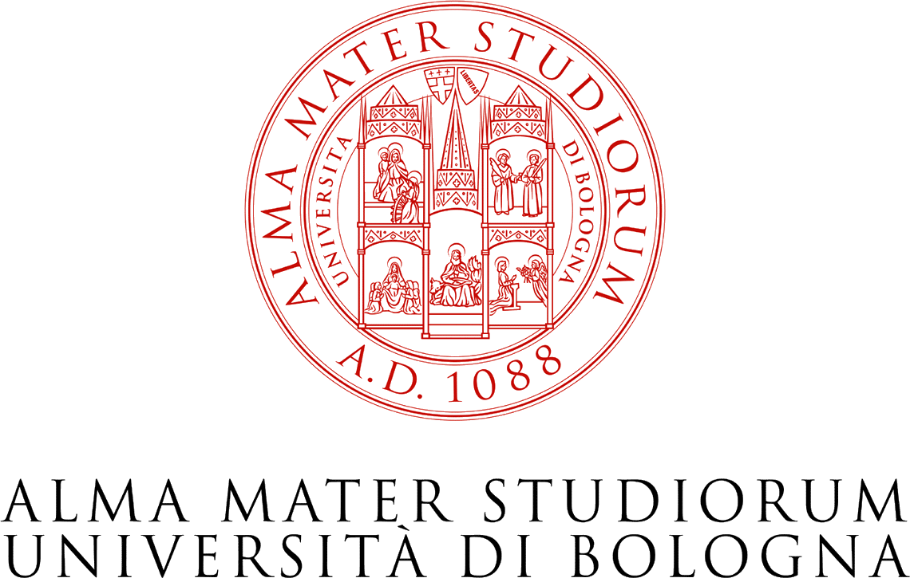

Research progress in Pharmacogenomics: personalized medicine and clinical translation July 5th- 6th 2018,
Aula Magna del Dipartimento di Farmacia e Biotecnologie, Università di Bologna

July 5th

14:30 Greetings from the Authorities
Santi M Spampinato (Direttore FaBiT), rappresentante SIF*

15:00 Lectio Magistralis - Munir Pirmohamed (Institute of Translational Medicine, University of Liverpool)
Pharmacogenomics of adverse drug reaction

Neurology
Chairpersons: Salvatore Terrazzino (University of Piemonte Orientale), Diego Fornasari (University of Milano)

- Alessandro Serretti - University of Bologna
Clinical application of pharmacogenetics in psychiatry
- Melissa Sorosina - San Raffaele Scientific Institute
Pharmacogenomics in multiple sclerosis: achievements, pitfalls and improvements
- Alessio Squassina - University of Cagliari
Pharmacogenomics of bipolar disorder
- Sarah Cargnin - University of Piemonte Orientale
The pharmacogenetics of migraine: where is it and where is it going
- To be selected from abstract

July 6th

Oncology
Chairpersons: Marzia Del Re (University of Pisa), Sabrina Angelini (University of Bologna)

- Gabriele Stocco - University of Trieste
Pharmacogenomics and personalized therapy of thiopurines in pediatric patients
- Gabriele Pizzino - Candiolo Cancer Institute, FPO - IRCCS, University of Torino Medical School
Genome editing redefines precision medicine in oncology
- Gloria Ravegnini - University of Bologna
Circulating molecules involved in clinical outcome in GIST
- To be selected from abstract
- To be selected from abstract
- To be selected from abstract

Coffee break

11:30-12:30 Lectio Magistralis - Ettore Capoluongo - "Policlinico Gemelli" Foundation, Catholic University of the Sacred Heart, Rome
Pharmacogenetics and cancer: ovarian and breast cancer updates

12:30 Lunch

14:00 Lectio Magistralis - Lisa Derosa - Gustave Roussy Cancer Campus, France
Translating bacteria into new cancer therapeutics

Immuno-oncology
Chairpersons: Marzia Del Re (University of Pisa), Giuseppe Toffoli (CRO Aviano)

- Eva Dreussi - CRO Aviano
Immunogenetics and prostate cancer: new prognostic biomarkers
- Gelsomino - Policlinico Sant’Orsola Malpighi, University of Bologna
Title to be decide
- Eleonora Rofi - University of Pisa
Therapeutic monitoring in NSCLC by liquid biopsy.
- To be selected from abstract

Coffee break

Cardiovascular
Chairpersons: Filippelli (University of Salerno)

- Valeria Conti - University of Salerno
The importance of Pharmacogenetics in patients at risk of thromboembolism
- Marco Cattaneo - University of Milano
Pharmacogenomics of oral anticoagulants
- Giulia Sammarini - University of Bologna
Relationship between Lipid Phenotypes, Overweight, Lipid Lowering Drug Response and KIF6 and HMG-CoA Genotypes in a Subset of the Brisighella Heart Study Population

18:00 Conclusions

